**Problem 1:**

The program is able to simulate a program with X elements (introduced by user) by page. The list where the program is getting the data comes from a file. All exceptions are handled. In order to do that, I created a list with sub-lists as elements. Each sub-list has the number of elements entered by the user. There are different methods to count total number of elements, number of elements per page, number of pages etc. Each method is based on the list of sub-lists.

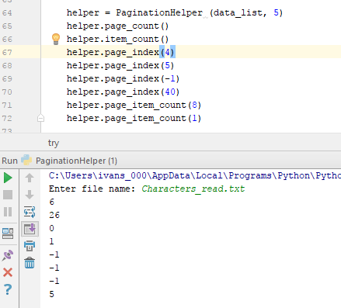

**Problem 2:**

This program simulates a “patientHelpter” where you can see the patients on the list with their information. You can also add and reach patients. In order to do that, we have a file with all the data. This file is read and each patient is added to a dictionary. Once we have our dictionary we can add patients to it. The dictionary is a key-value list where the key is the position of the patient in the file (that’s helps us to keep the patients always in order). Whenever we add a patient, at the end the program is going to check for new patients comparing the length of the dictionary and the number of lines in the file. If the length of the dictionary is greater than the number of lines, all the new patients will be added to the file. All exceptions are handled while reading the file or writing .The program will end just on the moment we call the exit method.

